INTRODUCTION IN THE ALGEBRIC FRACTURES, THE COSMIC PERSPECTIVE
Evolutionary Fractal Universe (GENESIS)
The tradition of Cartesian, dichotomous and linear thinking has created a great mass of information that projects certain behavioral patterns of the universe. However, the hypothesis of a qualitative and informational universe that does not use the Cartesian but hexagonal or polyhedral features allows understanding of other details about the universe, using a multivalent logic based on cyclic circuits or commutative diagrams. Each time we take a new thinking tool, we discover a coherent system of thinking that describes the unknown features of the universe.
Starting from the great mathematician Alexander Groetendich, the thinking on commutative diagrams and cycles tools has been widely opened. Somehow, with these tools, peace is made between the old Aristotelian thinking and the thinking of the sophists. This thought has not yet come into mathematics only on the surface, so this exploring will be difficult for readers. However, this way we develop concepts that decipher the secrets of the universe which have not yet been deciphered and which may be essential for our survival and the survival of the earth.
Basic definitions
Cyclic Circuits -> subgraphs with n nodes which contain a single cycle
Commutative diagrams -> subgraphs with n nodes in which a node has 2 inputs, another node has an input and output and the third node has two outputs.
More and more research and theories lead to the hypothesis that the universe is algebraic fractal type presenting structural isomorphisms between the levels of complexity. Another remarkable conclusion leads us to the existence of several fracturing formulas that reveal coherent structures in the analysis. Research in this direction is still in the beginning and we cannot tell whether the fracturing directions are finite or infinite.
Fractal universe -> there is no clear definition, but only certain features that you take as axioms in the fractal model.
The most probable working hypothesis is that of an evolutionary universe which manifests according to some rules from which we will enumerate a few :
- at each new level of complexity, the universe takes all possibilities of evolution (derived universes) towards a new, more complex structure
-If the iterations that have defined such a possibility can be done infinitely then we get a feature that becomes permanent. If iterations are possible in a finite number, then an ephemeral phenomenon that does not become universal occurs
- when two or more evolutionary possibilities (local universes) intersect (mutually influence each other) a big bang is formed, each of the two or more local universes being imprinted in structure by the other local universes
- If influences become coherent then a local subuniverse with complex properties and complex information imprints is obtained (eg life phenomenon, Lie E8 algebras for elementary particles, etc.)
-If there are inconsistencies in the information structure, then the hybrid universe degenerates and disappears (big crunch).
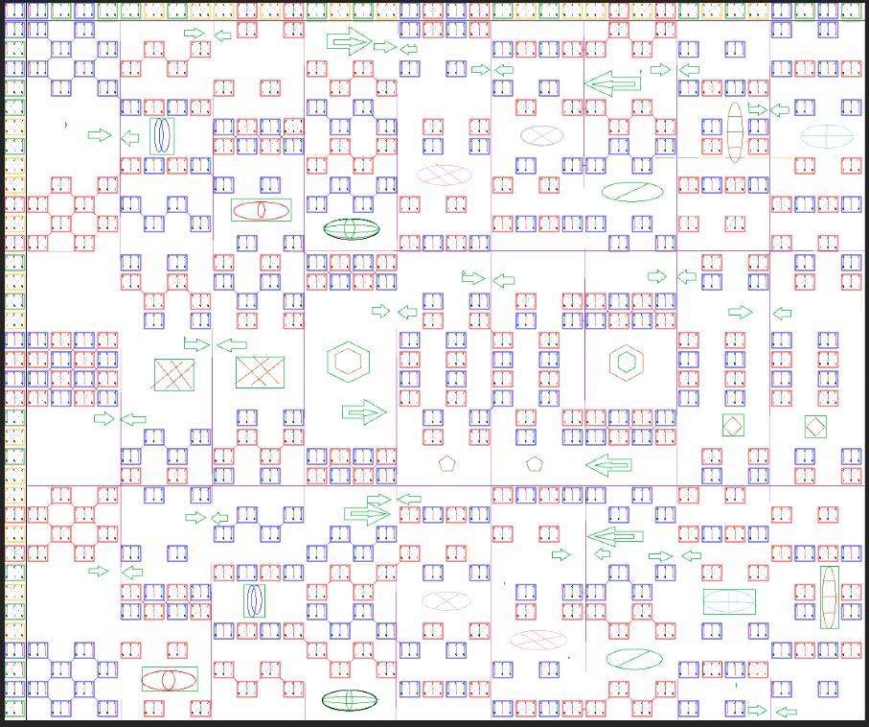
Fig. 1 The evolution of information that can be packaged or unwrapped (big bang, big crunch)
The algebraic fractal has the following characteristics:
- a tuple formed by the targeted graph, possibly some objects attached to the nodes and a concatenation law between the graphs
⦁ a network model that can be built from concatenation law
⦁ maintains similar network-level properties with the ones from the graphs level

Examples of algebraic fractals that generate local universes:
⦁ Coherent area of information (demonstrated consistency up to level 8, level packet repeating later) information ecology courses
https://www.hkrdi.org/ engl
⦁ Universal Alphabet Bogdan Cismariu http://89.46.7.10/sustain/tables.php
⦁ The address table of the organizations of the universe created by Andrei Jifcovici

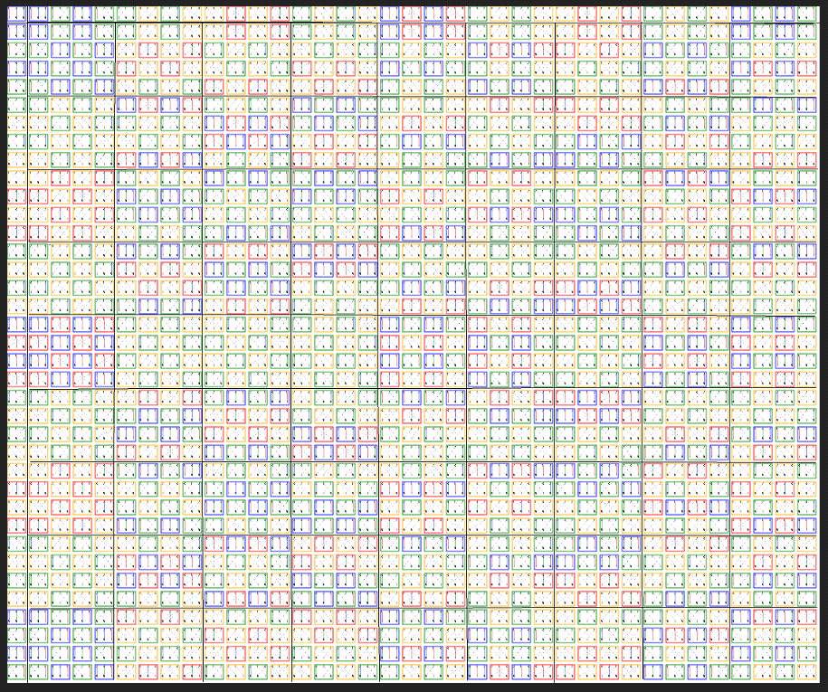
Fig. 2 the informational genome of the Universe
Like the living organism that has an informative code called the genetic code, the informational universe also has such a genetic code. Hence the extraordinary order and coherence of a universe, of life, which have similar existances , life and dead, birth and disappearance, evolution and adaptation to the new.
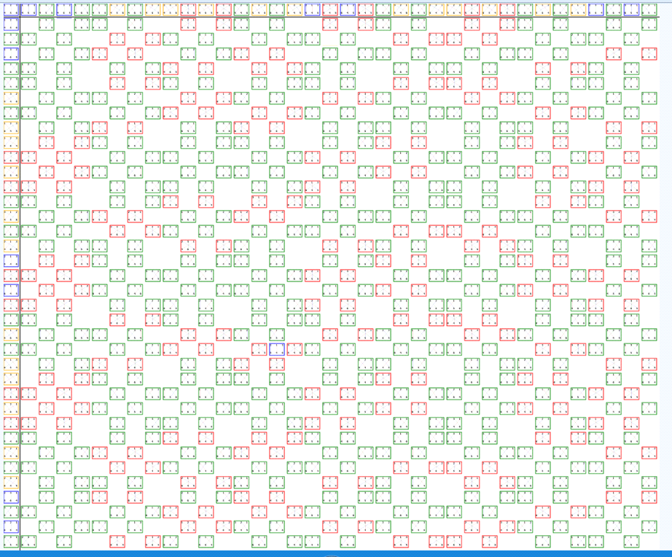
Fig. 3 example of universal law with measurable characteristics in the universe
Universal phenomena are diverse, some of them are evaluable and characterizable in equations, others are unpredictable. This phenomenon occurs at a quantum level, where phenomena can be described by Feinman integral and Feinman diagrams, but also at a macroscopic level, such as pendulums coupled with unpredictable movements, although the motion equations of each pendulum are well defined.
In the human body, as in the universal body, there is information that we have not yet deciphered either as a vocabulary, grammar, or semantic. However, the new perspective of thinking allows us to make a break in this direction, see "the art of thinking" and "the alphabet of the art of thinking, the universal language".
In our body information is transmitted through specific informational carriers from the cellular level to the body through multiple means. For example, structured water, hormones, electricity, RNA, microfibrils, and we have to confess that we do not know other ways yet, but they may exist. We do not know yet about the light that passes through the living body and which can very well be an information carrier. Until now, light was considered to have only physical characteristics, not informational characteristics.

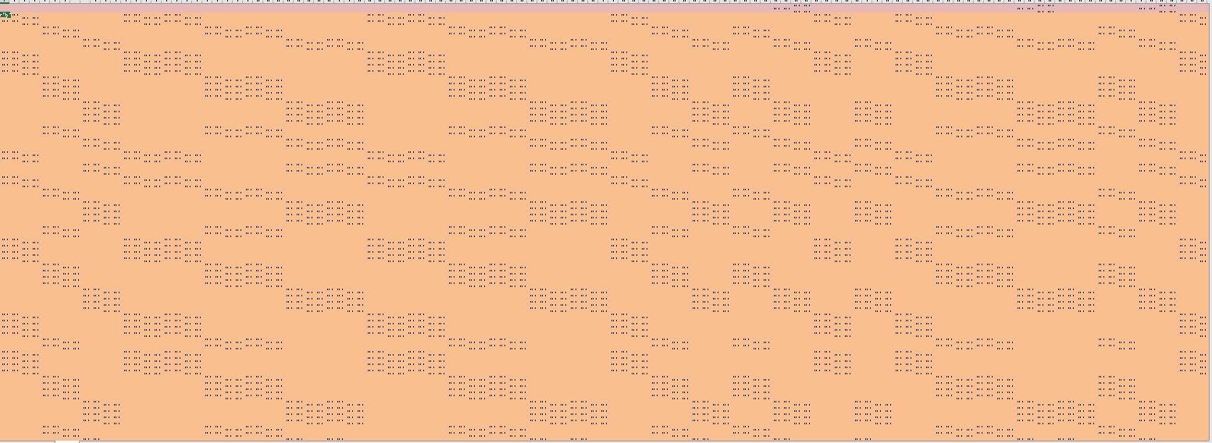
Fig. 4. Large information clusters that organize the universe, Example of coherent subuniverse obtained by superimposing algebraic fractals 2 and 3 is the paternity table described by Maria Mitrofan
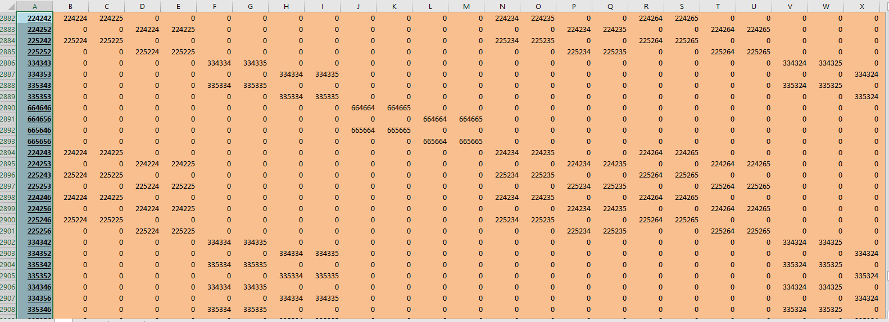
Fig. 5 the information that by concatenation forms the "words and semantics" of communication in the universe
For each work situation with universes and subuniverses, it is possible to discover specific physical or informational properties that are preserved, and if hybrid universes occur in the interference of experimental universes. The coherence of the universes generated by several derived universes occurs at the time of reiteration at various levels of granulation or fractalisation. Although each level has its own laws, all levels generated by the same hybridization phenomenon coexist. So the quarks, the elementary particles, the atoms, the molecules ... the galaxies or the big Sloane walls coexist. This coexistence is due to the structural isomorphism between the levels of complexity that can easily be confused with quantitative laws (eg the law of gravity) because of local or general behaviors similar to structural Isomorphism - see algebraic fractal definition, the property of similarity "are specific information structured with vocabulary, grammar, semantics starting from the letters. The letters of the universe are about 10 to the power 40, more than the number of atoms in the known universe, but how little we know about the universe or atoms.

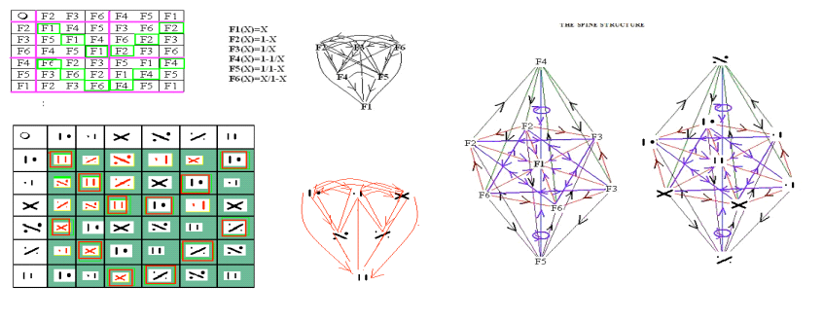
Fig. 6 The property of structural isomorphism
Another important detail in the metamorphosis of the universe is given by the coherence / incoherence ratio. This incoherence is obtained by changing the meanings of the information generating vectors, eg hexagonal feedbacks or diagrams.
Modifying vector arrows leads to quantitative aspects of flux size which completes with intensity or volume indicators of flow of the behavior data the of the lattice automatas generated. The fundamental difference between cellular and lattice automatas consists in covering the support space with identical quantifiable units (hexagons or polyhedral n dimensional structures that can project over hexagonal structures. From a physical point of view, the lattice automatas allow statistical characterizations as well as the observation of various details of probabilistic structure.
Movements or wave-like phenomena, for example can be explained using lattice automatas.
The speed of light or Plank's constant can be understood as phenomena that separate the metamorphosis development phases between two different levels of complexity of the universes.
Other physical phenomena can be understood as structural if we consider one of the generative algebraic fractal structures, and they will also be present in the hybrid universes obtained (eg. the principle of undetermination).

The Universal alphabet
The starting hypothesis is that of a universe based on feedbacks as primary information. These feedbacks are described as six-node unicast diagrams with six nodes sequentially covered by six vectors.
On the nodes there are the automorphisms of the projective straight line, and the engendering pattern of the nodes on the parallel lines is represented by oriented arches. This double vectoring visible through the unicast diagram and through the engendering pattern allows both the classification of feedback in classes and in class structures that generate behavioral self-similarity with the automorphisms of the the projective straight line. (https://sustainability-modeling.com/media/universul_informational.pdf); (https://sustainability-modeling.com/index.php?option=com_content&task=view&id=34&Itemid=1 ), (Universal alphabet; sustainability-modeling.com)

From the point of view of algebraic fractal theory, the choice of a standard model with six nodes of the unicast diagram corresponds to a choice that generates a fractal structure that can develop infinitely, thus having the ability to become a stable feature of the structure of the universe. see courses https://www.hkrdi.org/ and https://sustainability- modeling.com/index.php?option=com_content&task=view&id=34&Itemid=1.
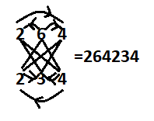
Fig. 7 a standard feedback with a unicast diagram
This is how a universal alphabet is generated. If, instead of the automorphisms of the projective straight line based on biraport and the preservation of three points in four, between 0, ½, 1 and infinite, an anarmonic report of k constant is chosen, a similar informational structure will be obtained confirming the multiverse hypothesis with sets of universal alphabets.
As the landmarks for the anarmonic report give three independent variables and one dependent one can understand why the physical manifestations are three-dimensional, the other dimensions of the universe being structural.
Feedback notation can be done on a geometric or algebraic image, the geometric one being more detailed, but the algebraic one that can be obtained from the geometric one is more compact.
In standard feedback, numbers are automorphisms. Feedbacks are grouped into feedback packs, which in turn form larger structures. The left scoring will be presented in the table by Bogdan Cismariu, as well as in the tables made by Andrei Jifcovici. Scoring variant 2 will be found in the tables generated by Maria Mitrofan.
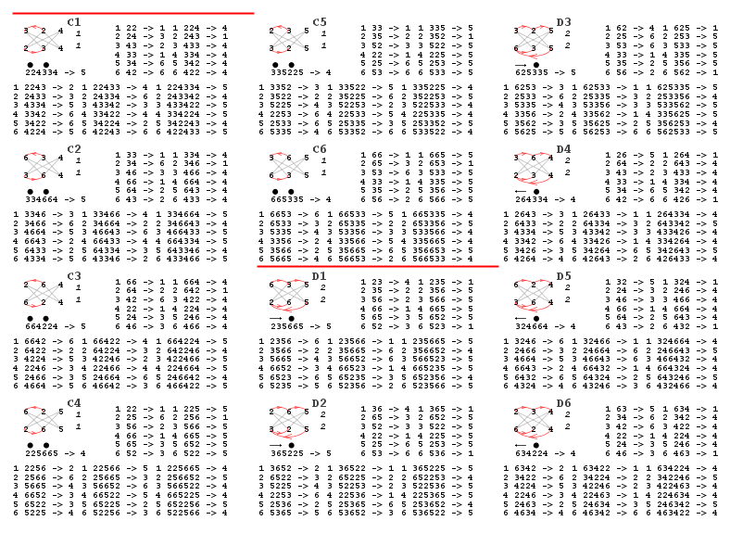
Fig. 8 examples of packing of feedbacks represented by letters of the universe
As a general principle, the hypothesis of the evolutionary universe leads to the conclusion of a phased development such as metamorphosis.
-the stage 1 the former universe has completed its metamorphosis and is moving to the chaotic development of new levels of complexity, preserving the previously stable structures
-the stage 2 the derived universes fractalise, some of whose fractals are finite disappear, others that can fracture endlessly become stable
- the stage 3 the existing universes at one stage hybridize from the core of the properties of the archaic universe and correlate the compatible informational structures between them. Also, the newly obtained structures if they can fracture infinitely become stable characteristics, if they do not have a lifetime after which they disappear (big crunch)
- the stage 4 creates a graph type compatibility structure between the remaining compatible universes that allows inter-relationships between universes (multiverse)
- the stage 5 the multiverse structure hybridises until it is completely structured and no internal evolution takes place
- the stage 6 proceeds to a qualitative leap of the entire structure while retaining all the stable characteristics obtained in the previous stages and restoring the cycle to a new level of metamorphosis.

The various mathematical tools developed starting from the measurability hypothesis are also an example of a fractal algebra that has been developed from the concept of number. They describe a measurable universe but can not fully approach the complex, dynamic, nonlinear or chaotic part of the universe. Taking into account the hypothesis of looking at the other three universes through the perspective of numerical mathematics, it is possible to identify the parts corresponding to the theories and identify the spatial phenomena to which they correspond.
Moreover, the various mathematical theories that can be synthesized in the group of invariants of the transformations they undergo can be considered as other algebraic fractals that by hybridization lead to other theories describing hybrid universes.

